**FOSSR**

**Fostering Open Science in Social Science Research**

Deliverable x.x

authors

date

|  |  |
| --- | --- |
| Project Acronym |  |
| *Agreement number* |  |
| *Project Full Title* |  |
| *Funding Scheme* |  |

DELIVERABLE INFORMATION

|  |  |
| --- | --- |
| Deliverable Number |  |
| *Deliverable Name* |  |
| *Dissemination level* |  |
| *Funding Scheme* |  |
| *Grant Agreement number* |  |
| *Contractual date of delivery* |  |
| *Deliverable Leader* |  |
| *WP/Task Responsible* |  |
| *Keywords* |  |
| *Abstract* |  |

DISCLAIMER

The content of this Deliverable reflects only the author’s view. The European Commission and MUR are not responsible for any use that may be made of the information it contains.

Document history

|  |  |  |  |  |
| --- | --- | --- | --- | --- |
| Date | Version | Contributor(s) | Description | Supervision |
|  |  |  |  |  |
|  |  |  |  |  |

Table of content

*1.* *Introduction 1*

**1.1** **FOSSR Objectives and Ambition 1**

**1.2** **Purpose and scope of this document 2**

*2.* *Titolo primo livello 2*

**2.1** **Titolo secondo livello 2**

2.1.1 Titolo terzo livello 2

*CONCLUSION 3*

*LIST OF ACRONYMS 3*

*ANNEXES 4*

Elenco Tabelle

Tabella 1 - Titolo 1

# Introduction

The background mission of the FOSSR project relies on creating and strengthening awareness and knowledge of data and methodologies used in empirical social sciences among a wide audience, through maintaining and reinforcing of relevant Research Infrastructures (RI) , while fostering the development of a research and social environment conducive to an open, shared and simplified data access via innovative interfaces. The project will concretely contribute to the effective implementation of the ‘open science’ for social science researchers by providing innovative tools and services for research, shared virtual environment for data access and a wide and varied package of training courses, sessions and programmes (FOSSR DoW, 2022).

FOSSR adopts the common theme of the development of Open Science in the Italian context with the goal of creating a framework of tools and services for the social science scholar community involving the Rls in social sciences coordinated by CNR, namely CESSDA, SHARE and RISIS. The framework should take the form of an integrated knowledge sharing platform, a single point of access to all the tools and services made available by the Italian nodes of social science infrastructures.

FOSSR fosters the building of an Italian Open Science Cloud, along the lines of the European Open Science Cloud project, in which to integrate innovative services developed by the project for data col- lection, data curation and fairness and data analysis on economic and societal change.

FOSSR wants to promote toward multiple audiences, a widespread knowledge and awareness of the data and methodologies employed in empirical social science, fostering the growth of a broad societal environment favorable to further thriving of social science research in Italy, providing easy, open, streamlined access to social science data through innovative interfaces

## FOSSR Objectives and Ambition

FOSSR has the general aim of promoting, towards multiple audiences, a widespread knowledge and awareness of the data and methodologies employed in empirical social science, by providing (i) systematic and organized knowledge (also through summary harmonized data) about available social science data resources in Italian data archives, especially the CESSDA Archive, already object of the grand infrastructural proposal; (ii) resources supporting methodological advancement as to data collection and data analysis, especially important for RISIS to understand the design, the implementation, and the outcome of research and innovation policies, which can improve the robustness of empirical evidence produced for policy makers and to deal with new research questions, and (iii) tools and services to make publicly available advanced probability panels for longitudinal analyses to support important survey such as SHARE, complementing them with a network of online laboratories. The integration of this pool of resources shall concretely contribute to the realization of open science for scholars in social sciences, going with an important program of scientific training for the production and analysis of social science based on FAIR empirical data.

One further key objective is setting a new generation of young researchers in social sciences, by hiring several researchers and technologists with fixed time contracts, which will become highly skilled human resources in data science and data management in social science research, and by funding PhD positions to train early career researchers in the field.

FOSSR is also aimed at fostering the growth of a broad societal environment favorable to further thriving of social science research in Italy, providing easy, open, streamlined access to social science data through innovative interfaces (data exploration portals, time series,interactive visualizations), and through online data analysis software aimed at students, along with divulgation resources about social science methodology. These aspects are particularly aimed at civil society organizations (NGOs, etc.), students, ordinary citizens, to foster a widespread societal awareness of social science data, results, methods to promote an easier and more user-friendly dissemination.

The main investment shall be on the creation of a suitable IT infrastructure and a network of data center to provide researchers access online and onsite, and to support the workflow of the proposed collaborative projects. One of the subsequent goals of FOSSR will be to develop innovative tools and services for data collection and data analyses, and to support participating users in the acquisition and use of advanced equipment and software for social science research needed for collaborative studies and projects. The achievement of the above-mentioned goals can be reached by means of an online platform – the Open Cloud, acting also as a dissemination layer, intermediating between data producers, archives, and the broader shop floor of users (both scholars and stakeholders), assuring access intermediating between data producers, archives, and the broader shop floor of users (both scholars and stakeholders), assuring access also to multiple software interfaces, geared at different audiences, methodological content, and training materials.

## Purpose and scope of this document

# Titolo primo livello

Nel corpo del testo quando si indica un link seguire la seguente impostazione, [sito del MUR](https://www.mur.gov.it/it)[1] ….

## Titolo secondo livello

I paragrafi dovrebbero essere di formato corpo del test

### Titolo terzo livello

Il corpo del testo dovrebbe essere in funzione

# CONCLUSION

# LIST OF ACRONYMS

# ANNEXES

Per quanto riguarda gli elenchi numerati

1. Elenco numerato primo paragrafo
2. Secondo paragrafo
3. …..

Per quanto riguarda gli elenchi puntati:

* Provo l’elenco puntato
* Con due livelli
* Secondo livello

*Tabella 1 - Titolo*

|  |  |  |  |
| --- | --- | --- | --- |
| Formato tabella |  |  |  |
|  |  |  |  |
|  |  |  |  |

Importante considerare l’aspetto cromatico della tabella. Valutare caso per caso se procedere alla chiusura della prima e ultima colonna

*D:\Users\CanelaperezM\AppData\Local\Microsoft\Windows\INetCache\Content.MSO\E30E9B69.tmp FOCUS*

*Eventuale box[2] di approfondimento su linee guida di selezione avvisi MUR (ove realizzati)*

Di seguito i colori utilizzati per il focus e in generale per le tabelle

|  |  |  |  |
| --- | --- | --- | --- |
| Sfondo Focus | Righe di contorno | Testo | Sfondo Box/ Intestazione colonne |
|  |  |  |  |

I colori scelti si trovano tutti nella 2’ colonna *dei colori standard di Word* iniziando da destra

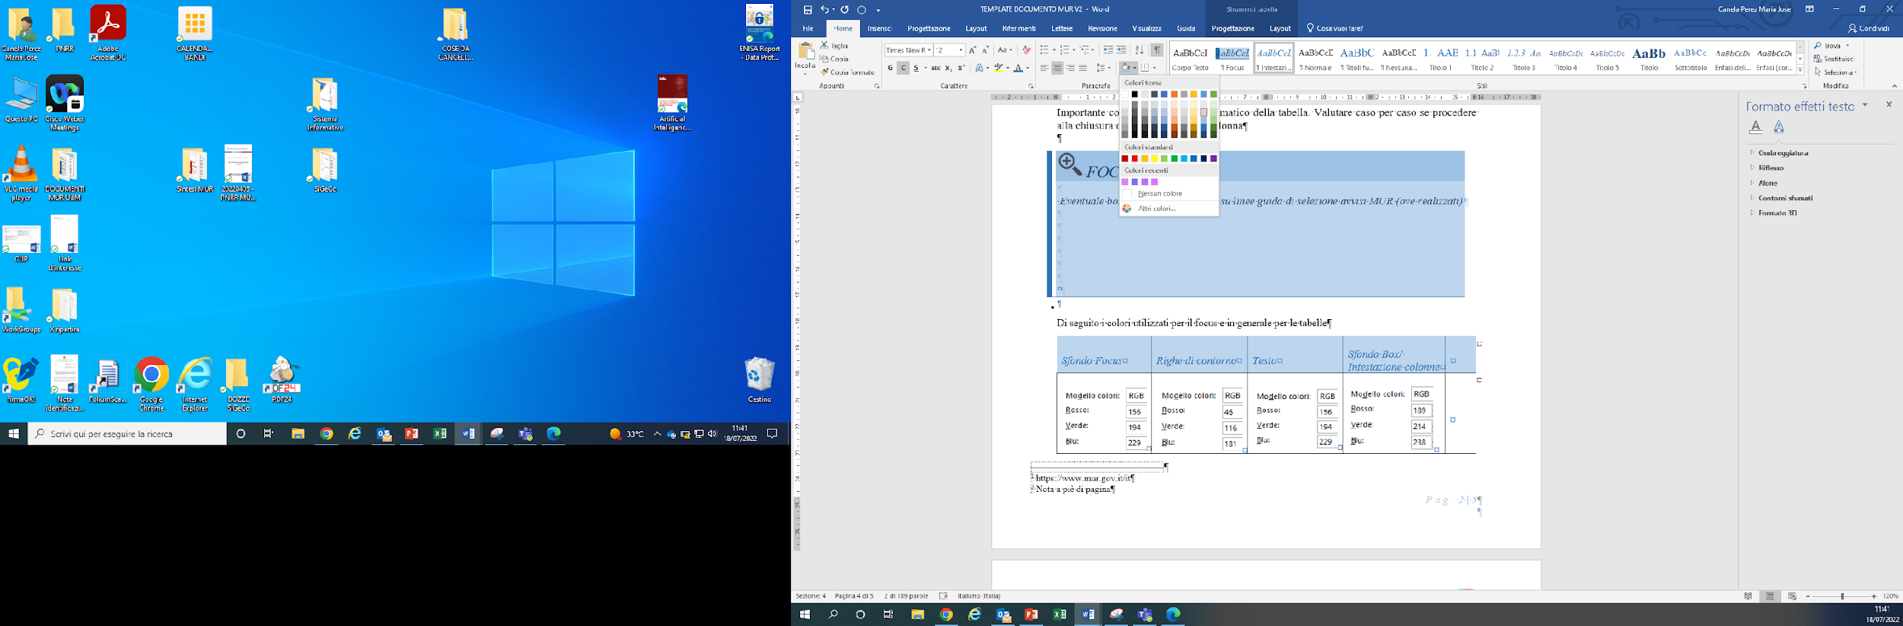

1. https://www.mur.gov.it/it
2. Nota a piè di pagina